NOUNS | Nom. Sg. | Acc. Sg. | Gen. Sg. | Dat. Sg. | Nom. Pl. | Acc. Pl. | Gen. Pl. | Dat. Pl. | I | You | He/She/It | We | Y’all | They | 2nd Sg. Imperative | 2nd Pl. Imperative | VERBS
λόγος |  |  |  |  |  |  |  |  |  |  |  |  |  |  |  |  | βαίνω
ἀνήρ |  |  |  |  |  |  |  |  |  |  |  |  |  |  |  |  | οἶδα
θεά |  |  |  |  |  |  |  |  |  |  |  |  |  |  |  |  | λέγω
ναῦς |  |  |  |  |  |  |  |  |  |  |  |  |  |  |  |  | δουλόομαι
γείτων |  |  |  |  |  |  |  |  |  |  |  |  |  |  |  |  | ἡσυχάζω
νῆσος |  |  |  |  |  |  |  |  |  |  |  |  |  |  |  |  | ἔρχομαι
θύρα |  |  |  |  |  |  |  |  |  |  |  |  |  |  |  |  | σῴζω
ἔργον |  |  |  |  |  |  |  |  |  |  |  |  |  |  |  |  | φροντίζω
νύξ |  |  |  |  |  |  |  |  |  |  |  |  |  |  |  |  | ὁράω
πόλεμος |  |  |  |  |  |  |  |  |  |  |  |  |  |  |  |  | μένω
νίκη |  |  |  |  |  |  |  |  |  |  |  |  |  |  |  |  | εἰμί
νεώριον |  |  |  |  |  |  |  |  |  |  |  |  |  |  |  |  | διώκω
σωτήρ |  |  |  |  |  |  |  |  |  |  |  |  |  |  |  |  | ποιέω
βοή |  |  |  |  |  |  |  |  |  |  |  |  |  |  |  |  | βλέπω
ῥαψῳδός |  |  |  |  |  |  |  |  |  |  |  |  |  |  |  |  | γίγνομαι
πράγμα |  |  |  |  |  |  |  |  |  |  |  |  |  |  |  |  | τολμάω

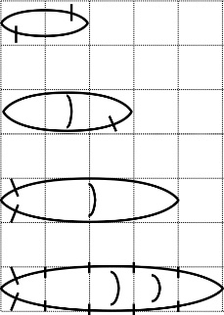
Papyrela (2 long)

Fishing boat (3 long)

Freight ship (4 long)

Trireme Warship (5 long)
Salamis, Isle Divine
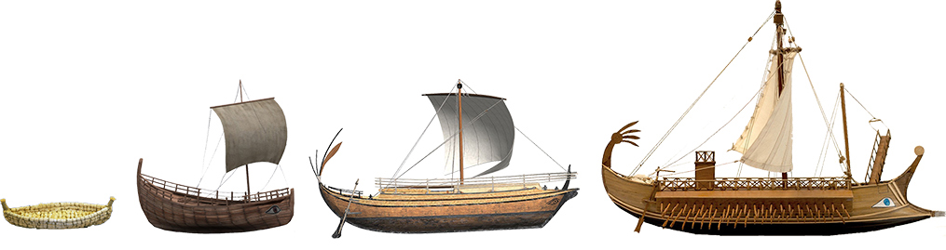

Game Objective

The object is to try and sink all the other player's ships before they sink all of yours.
Keep your page hidden so that your opponent won’t know where your ships are hiding!

Starting a New Game

- Each player places 4 ships somewhere on their board:
Papyrela (2 long)

Fishing boat (3 long)

Freight ship (4 long)

Trireme Warship (5 long)

- The ships can only be placed vertically or horizontally (Not diagonally)
- Ships may not overlap each other.
- Players may not move the ships.

Playing the Game

- Take turns trying to hit each other’s ships by guessing the X/Y coordinates.
- The opponent will respond by saying if the guess is a ‘miss’ or ‘hit’ a ship.
- Mark your guesses on the page: O=Miss, X=hit
- Mark your opponent’s guesses that hit your ship: ‘#’ = Hit by your opponent
- Announce “You sank my [ship]” when your opponent hits all of a ship’s squares
- As soon as all of one player's ships have been sunk, the other player wins!

